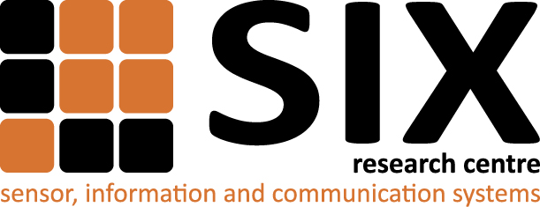
SIX Research Center: full operation starting
(perex) Brno, the 15th of November 2013 – Thanks to the project Center of Sensor, Information and Communication Systems (SIX), Brno University of Technology has established and equipped a research center which strongly cooperates with companies applying information and communication technologies in different areas of a practical life.
The SIX project was started on the 1st of August 2010 and will be finished on the 31st of December 2013. For the implementation of the SIX project, the registration number CZ.1.05/2.1.00/03.0072, the operational program Research and Development for Innovation allocated the total financial subsidy in the amount of CZK 293 781 336.00. The European Union has been providing CZK 249 714 135.60 and the state budget of the Czech Republic has been granting CZK 44 067 200.40.
A unique research infrastructure built within the SIX project can contribute to boosting the research in the SIX Center which is focused on electronic systems and components to be applied in near future. That way, an innovation potential of cooperating bodies can be significantly strengthened.
Since the SIX Center is a part of the technical university, SIX research and development can benefit from interactions with students, can exploit outputs of independent research done by academicians, and rich international contacts of researchers and professors.
In the 1st of January 2014, the full operation of the SIX Center will start.
Contact:
Prof. Zbynek Raida
SIX, Brno University of Technology
Technicka 12, 616 00 Brno, Czech Republic
Email: six@feec.vutbr.cz
WWW: http://www.six.feec.vutbr.cz

